Bridge Rectifier (Its working principle, uses and drawbacks)
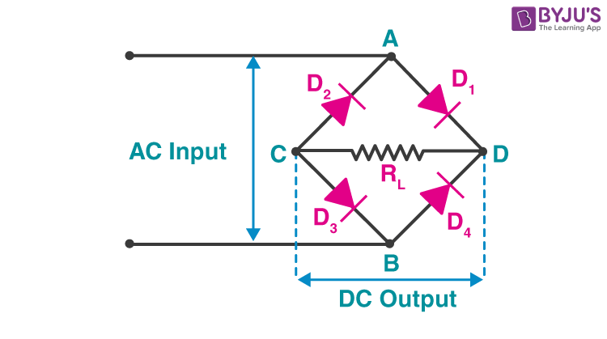
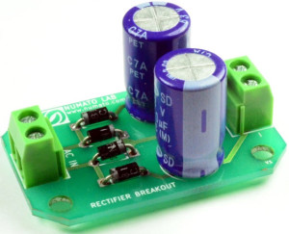

https://www.elprocus.com/bridge-rectifier-circuit-theory-with-working-operation/

https://byjus.com/physics/bridge-rectifier/

